**Instructions to Run bash scripts on Windows.**

1. Install **Windows Subsystems for Linux(WSL)** on Windows.

Go to Settings > Update & Security > For Developers. Check the Developer Mode radio button. And search for “Windows Features”, choose “Turn Windows features on or off”.

Scroll to find WSL, check the box, and then install it.

<https://www.microsoft.com/en-us/p/ubuntu/9nblggh4msv6?activetab=pivot:overviewtab>

2. Change the **port names on bash script** as follows.

Linux default port after device connected >>>> /dev/ttyACM0

Windows port after device connected >>> COM18

Change it on the script as >>>> /dev/ttyS18

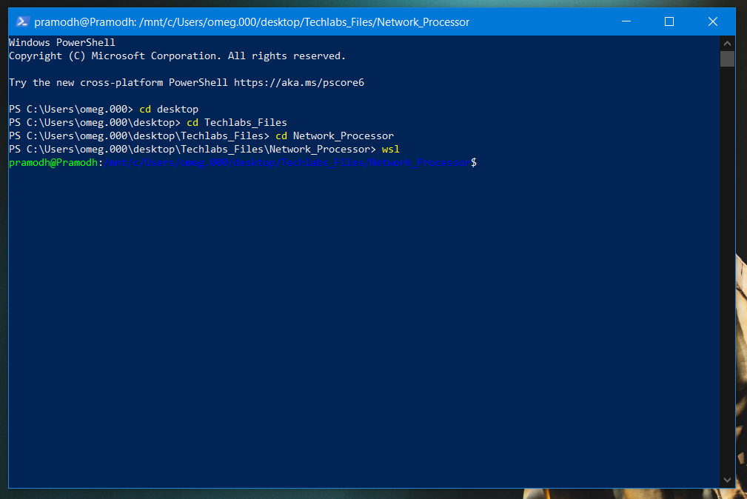3. **Run** the script using windows Power Shell.

2. Run WSL here

1. Direct into the folder

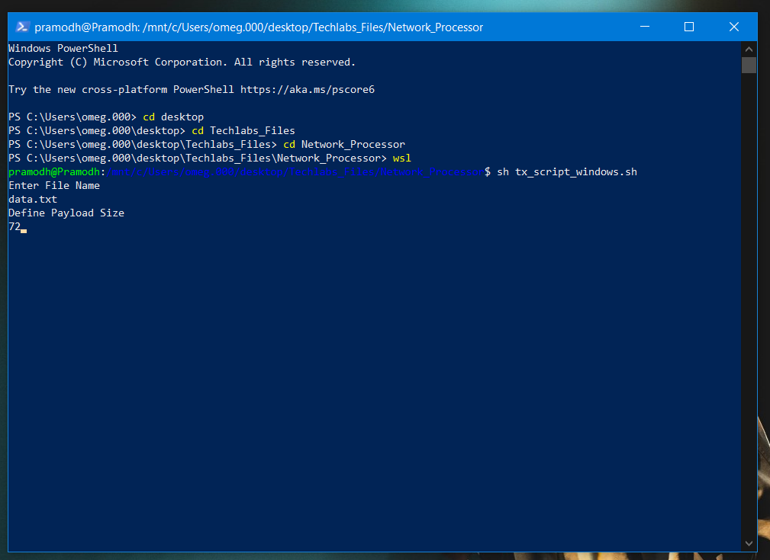

File which contains image data stream

3. Now bash scripts can run on Windows